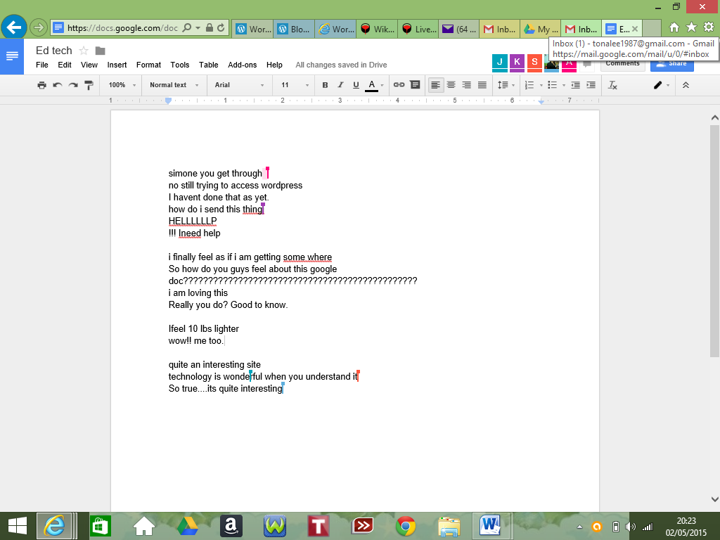
Google docs url - https://docs.google.com/document/d/1xGr8b2iWG0ctnuUYk4Cm10g7RZN0lXlwlln9fRfwVV4/edit

