My House on the Highway
Author Suzette Ferguson
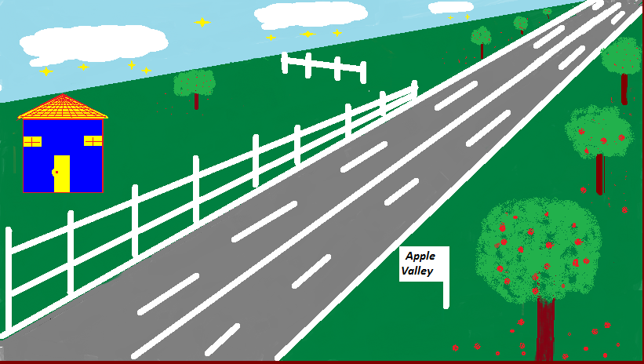

I live in a blue and yellow house in Apple Valley. It is on the highway. My house is the first and miles apart from the second one.

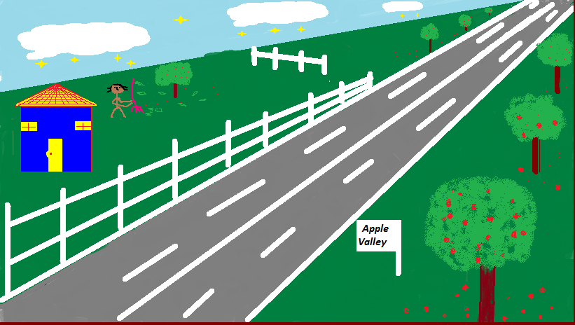

One Sunday evening my mother was outside raking the leaves from under the big apple tree in our yard.

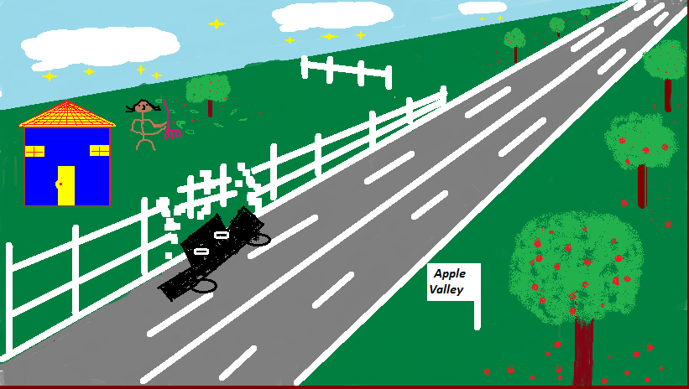

To her surprise a black car overturned and tore down the fencing. Luckily no one was hurt.

